**Homework 5**Lesson: Behavioral FinanceStudent Name: Zhao EnpingClass: G1

**Part 1: Plot the price-dividend ratio (on the vertical axis) vs b0 (on the horizontal axis).**

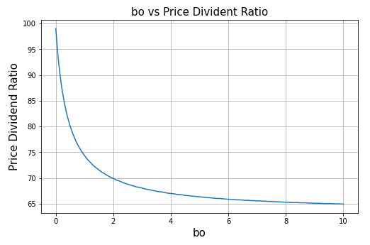

**Part 2: Plot the equity premium (on the vertical axis) vs b0 (on the horizontal axis).**

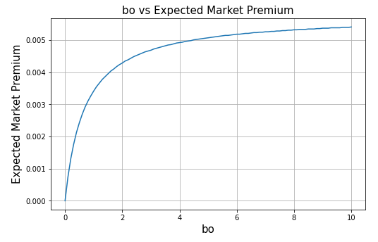

**Economic significance**:

1. Investor's utility function for financial gain or loss [i.e., Nuhat (R)]:

Nuhat (R) allows us to incorporate the prospect theory, because it considered the impact of investor’s financial gain or loss to the utility function. where the impact to the utility from financial gain or loss is measured relative to reference level based on risk-free rate.

1. Parameter lambda.

Parameter lambda is the degree of loss aversion. Investor is more sensitive to financial loss than financial gain, therefore lambda should always be greater than 1. The bigger the lambda, the more sensitive the investors are towards financial losses.

1. Parameter b0

Parameter b0 determines amount of emphasis that investor puts on utility from financial gain or loss, compared to utility of consumption. Equity premium will increase as b0 become larger, because investors puts more emphasis in utility from financial gain or loss.

**Appendix:**

